Subject Story: Forest School
In our Forest School curriculum you will see our value of Friendship.  - Children work closely with their peers to achieve common goals helping them to develop and strengthen their friendships and to learn and apply social skills like negotiation, conflict, resolution and diplomacy  - The promotion of social skills through group games and activities will enable children to better communicate with others and develop positive friendships and relationships | In our Forest School curriculum you will see our value of Responsibility.  - Children are responsible for using ‘real’ tools safely  - Children learn about fire safety when around the fire circle  - Children are responsible for looking after their Forest School environment  - Children are aware of the Forest School rules and how to apply them |  | In our Forest School curriculum you will see our value of Honesty.  - Children are given the freedom to make decisions about their own learning which empowers them.  - Children know that it is ok to make mistakes  - Children are given time to reflect on their learning  - Adults model honest and positive attitudes
In our Forest School curriculum you will see our value of Love.  - Love for the environment  - Empathy for living creatures  - Care for their surroundings  - Children experience the seasons and wonders of nature | In our Forest School curriculum you will see our value of Courage.  - Children achieve and develop confidence and self-esteem through hands-on learning experiences  - Children are encouraged to take managed risks to become more resilient learners  - Children will be encouraged to challenge themselves during activities to broaden their knowledge and skills |  | In our Forest School curriculum you will see our value of Respect.  - Forest School enables children to be more respectful of the environment and living things  - Children demonstrate respect when listening to their peers during class reflection
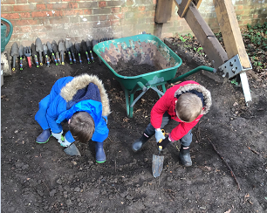 |  | Children at St. Martin’s say this about Forest School:  “My favourite thing to do is den building with my friends”  “I like the mud kitchen, we pretend we are baking”  “I like to dig for treasure”  “I love to sit and draw the beautiful flowers”  “We get to make really cool things using tools”

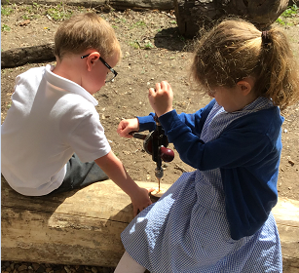 | If you were to walk into a Forest School session at St. Martin’s you would see:  - All learners engaged in a variety of activities  - Learners being challenged in a range of activities  - Shelter & den building  - Wildlife studies  - Digging activities  - Sensory activities  - Cooking on an open fire  - Tool use  - Woodland crafts  - Scavenger & Mini-beast hunts  - Team games  - Children taking ownership of their learning  - Imaginative play  - Holistic learning  - Collaborative learning  - Inclusive learning | In our Forest School curriculum you will see children learning through exciting, engaging learning experiences which develop their ‘cultural capital’.  - Our Forest School is a place where children develop a relationship between themselves and the natural world  - The freedom to explore using multiple senses is fundamental for encouraging creative, diverse and imaginative play
Our agreed consistencies for Forest School are:  - We use our natural wooded environment to support the development of a relationship between the learner and the natural world.  - We promote holistic development, fostering resilient, confident, independent and creative learners.  - We offer learners the opportunity to take supported risks appropriate to the environment and to themselves.  - We use a range of learner-centred processes to create a community for development and learning |  | 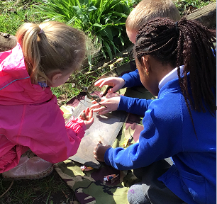Image
In our Forest School curriculum you will see our school curriculum vision because our children work with resilience – strive.  - Children demonstrate resilience by adopting a ‘can do’ attitude when using tools to make objects  - Children are challenged to try new activities | In our Forest School curriculum you will see our school curriculum vision because our children dream big - aspire.  - Forest School supports the development of life long skills such as self-belief, self-esteem, self-regulation, empathy & social skills which are essential skills for a child’s future | In our Forest School curriculum you will see our school curriculum vision because our children flourish - succeed.  - Forest School is a child-centred inspirational learning process, that offers children opportunities for holistic growth

In our Forest School curriculum you will see that we value inclusion and diversity.  - Activities are diverse and accessible to all children  - We use different materials and food to celebrate each child’s individual cultural background and beliefs | 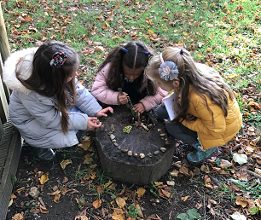Image | In our Forest School curriculum you will see how we develop our children’s language, including subject specific and technical vocabulary.  - The sensory experiences that Forest School provides helps prompt language development  - Specific vocabulary taught within Forest School can be found within our ‘knowledge and skills progression’ documents which links to the Early Years & National curriculum
British Values and Spiritual, Moral, Social and Cultural Learning (SMSC) in Forest School:  - Spiritual: The power of Forest School makes it valuable in overcoming problems, working together and creating a sense of awe and wonder.  - Moral: Children experience the relationship between their actions and the natural world  - Social: Children develop their sense of identity and belonging. Activities engaged with in an outdoor environment often help to develop communication, co-operation, compassion and emphasise the importance of certain rules and boundaries  - Cultural: Forest School allows children to develop values and opinions that are informed by first-hand experiences of the natural world. This helps them to appreciate the natural world and have an experience of flora and fauna which they might not usually encounter |  | Children achieve well in this subject. Highlights of outcomes in Forest School for last academic year are:  - Motivation: High levels of interest lead to high levels of attention and participation  - Physical Skills: Development of fine and gross motor skills, stamina and co-ordination through active learning  - Confidence: Increased self-confidence and self-esteem due to freedom, time and space. Children demonstrate independence. Children make decisions and evaluate risk.
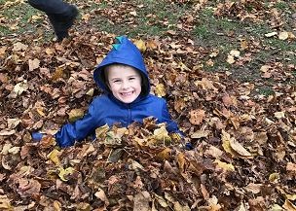  . .. | Successes in 2023-2024  - Designated Welly shed for years 2-6  - Rethink Waste Campaign Winners - £750 funding secured to build a bird hide & sensory garden  - Parachute cooking area  - Re-wilding wildflower area  - Forest School sessions for years 5 & 6  - Forest School ‘Winter Wonderland’ event | Priorities for 2025-2026  - Redevelopment of pond area  - Completion of Bird Hide & Reflection area  - Expand loose-parts inventory to enhance exploratory, hands-on learning opportunities  - Increase wildlife-rich areas to deepen nature connection

